

**SIMATS SCHOOL OF ENGINEERING**

**SAVEETHA INSTITUTE OF MEDICAL AND TECHNICAL SCIENCES**

**CHENNAI-602105**

**Online Bus Ticket Booking System**

**A CAPSTONE PROJECT REPORT**

*Submitted in the partial fulfillment for the award of the degree of*

**BACHELOR OF ENGINEERING**

**IN**

**COMPUTER SCIENCE AND ENGINEERING**

**Submitted by**

**K.Dhatri Parvathi Swetha(192210372)**

**S.Tejasree(192210243)**

**M.Tejaswi(192210391)**

**Under the Supervision of**

**Yuvaraj**

**September 2024**

**DECLARATION**

We, K.D.P.Swetha,S.Tejasree,M.Tejaswi, students of **Bachelor of Engineering in Information Technology**, Department of Computer Science and Engineering, Saveetha Institute of Medical and Technical Sciences, Saveetha University, Chennai, hereby declare that the work presented in this Capstone Project Work entitled **Online Bus Ticket Booking System** is the outcome of our own bonafide work and is correct to the best of our knowledge and this work has been undertaken taking care of Engineering Ethics.

K.Dhatri Parvathi Swetha(192210372)

S.Tejasree(192210243)

M.Tejaswi(192210391)

Date:

Place: CHENNAI.

**CERTIFICATE**

This is to certify that the project entitled **“Online Bus Ticket Booking System”** submitted by K.D.P.Swetha,S.Tejasree,M.Tejaswi has been carried out under my supervision. The project has been submitted as per the requirements in the current semester of B. Tech Information Technology.

Teacher-in-charge

**Yuvaraj**

**Table of Contents**

|  |  |
| --- | --- |
| **S.NO** | **TOPICS** |
| 1 | **Abstract** |
| 2 | **Introduction** |
| 3 | **Project Description**  About your project |
| 4 | **Problem Description**  Program to build a simple Software for < > |
| 5 | **Tool Description**  User interface  Features |
| 6 | **Operations**  Store the First name of the student.  Store the Last name of the student.  Store the unique Roll number for every student.  Store the CGPA of every student.  Store the courses registered by the student. |
| 7 | **Approach / Module Description / Functionalities**  The idea is to form an individual functions for every operation. All the functions are unified together to form software. |
| 8 | **Implementation**  Coding |
| 9 | **Output**  Output with Screenshots |
| 10 | **Conclusion**  Future Enhancement  **References** |

**ABSTRACT :**

In an era where convenience and efficiency are paramount, the need for a reliable and user-friendly bus ticket booking system has become increasingly important. This project aims to develop an intuitive web-based bus ticket booking platform that caters to passengers and administrators alike. The system allows users to search for buses by route, date, and time, view available seats, and securely book tickets online. Additionally, users can create and manage accounts, check booking history, and cancel tickets through a personalized dashboard. Administrators have access to a comprehensive admin panel to manage bus schedules, user accounts, and generate reports. The platform integrates a secure payment gateway to ensure the safety of transactions and is mobile-responsive to offer seamless access on all devices. By addressing the challenges of traditional booking methods, our platform redefines the bus travel experience with a focus on convenience, security, and scalability, making it a versatile solution for users and operators.

**INTRODUCTION :**

The **Online Bus Ticket Booking System** is a web-based platform designed to streamline the process of booking bus tickets for travellers. It provides an efficient and user-friendly experience for both customers and administrators. This system enables users to search for buses based on route, date, and time, view available seats, and make bookings online, ensuring a hassle-free travel experience. Additionally, the system offers robust management features for admins to handle bus schedules, user accounts, and bookings.

**Key Features:**

1. **User Account Management**:
   * Users can create an account, log in, and manage their profile and bookings.
   * The login module includes user authentication, change password, and forgot password functionalities.
   * Once registered, users can access a personal dashboard to manage their bookings and view their booking history.
2. **Bus Search and Booking**:
   * Users can search for buses based on specific routes, travel dates, and times.
   * They can view the available seats and select their preferred seats during the booking process.
   * The system supports secure payments through integrated payment gateways, providing users with a seamless checkout experience.
3. **Admin Panel**:
   * The admin panel offers comprehensive management tools for bus schedules, seat availability, and user accounts.
   * Admins can add, update, or delete bus information, including details like bus type, location, and available seats.
   * The system also allows admins to manage bus categories, such as Volvo, sleeper coach, etc., and handle user comments and feedback.
4. **Booking and Cancellation**:
   * Users can easily book their tickets by selecting a bus, choosing seats, and filling in passenger details.
   * The system also allows users to cancel their bookings if needed, and refunds are processed according to the cancellation policy.
5. **Comments and Feedback**:
   * The platform includes a comments module, where users can post feedback about their bus experience. This feedback can be managed by the admin.
6. **Report Generation**:
   * The system supports report generation, allowing admins to generate and view reports related to bookings, cancellations, user registrations, and more.

**Mobile Responsiveness:**

The system is designed to be mobile-responsive, ensuring that users can access it on a variety of devices, from desktops to smartphones, without compromising on functionality or usability.

Overall, the **Online Bus Ticket Booking System** aims to simplify bus ticket booking for users while providing administrators with powerful tools to manage bus services effectively.

**PROJECT DESCRIPTION**

This project focuses on developing a comprehensive web-based bus ticket booking system that leverages modern web technologies to offer a seamless experience for both passengers and administrators. Users can search for buses based on various criteria such as route, date, and time, view available seats, and complete bookings through an integrated and secure payment gateway.

Key features include a registration and authentication system that enables users to create accounts, log in, and manage their profiles. The platform offers a personalized dashboard where users can view and manage their bookings, access booking history, and cancel tickets if needed. The system is designed to be mobile-responsive, ensuring a smooth experience across different devices.

From an administrative perspective, the platform provides tools for managing bus information, schedules, and categories (e.g., Volvo, Sleeper coach). Admins can also generate reports to analyze bookings, revenue, and system performance. The admin panel facilitates efficient management of user accounts, comments, and news updates, enabling operators to maintain control over their operations.

**TOOL DESCRIPTION :**

User Interface:

The user interface (UI) of the bus ticket booking system is designed for ease of use, ensuring that both passengers and administrators can navigate the platform without difficulty.

1. Dashboard:
   * Passenger Dashboard: Displays upcoming trips, booking history, and personalized travel suggestions. It offers easy access to booking management and seat selection.
   * Admin Dashboard: Provides a comprehensive overview of bus schedules, booking statistics, and user management tools. Admins can quickly access features to manage buses, schedules, and generate reports.
2. Bus Information Management:
   * Drag-and-Drop Tools: Allows admins to add or update bus information by simply dragging and dropping elements such as photos, descriptions, and schedules. Pre-built templates are available for faster updates.
   * Category Management: Admins can manage different bus categories (e.g., Volvo, Sleeper coach) and define the available seat types.
3. Navigation:
   * Intuitive Menus: The system uses clear and concise menus to help users navigate through booking options, schedules, and seat selections.
   * Search Functionality: Advanced search tools allow users to find buses based on routes, dates, and specific criteria such as available seat types.

**FEATURES:**

1. Registration and Authentication:
   * Flexible Registration: Supports multiple registration methods, including email and social media logins.
   * Secure Authentication: Robust security measures ensure secure access to the platform. Includes options for two-factor authentication (2FA) to enhance security.
2. Booking Process:
   * Seat Selection: Users can view available seats on a selected bus and choose their preferred seating arrangement.
   * Secure Payments: Integration with a secure payment gateway ensures that all transactions are safe and compliant with relevant standards.
   * Booking Confirmation: Users receive confirmation emails and can access their bookings via the dashboard.
3. Booking Management:
   * Ticket Cancellation: Users can cancel bookings and receive refunds based on the cancellation policy.
   * Booking History: A comprehensive history of past bookings is available for users to review.
4. Comments and Reviews:
   * User Comments: Passengers can leave comments on their experiences with a specific bus or service, allowing for feedback and engagement.
5. Admin Controls:
   * Bus Management: Admins can update bus schedules, categories, and seating arrangements.
   * User Management: Manage registered users, review comments, and respond to feedback.
   * Report Generation: Generate detailed reports on bookings, revenue, and user engagement to analyze the system's performance.
6. Mobile Responsiveness:
   * Cross-Device Compatibility: The platform is designed to be mobile-responsive, ensuring a consistent experience across desktops, tablets, and smartphones.

**OPERATIONS :**

• **System Setup and Maintenance:**

* **Bus Information Configuration:** Admins can set up bus schedules, categories, and availability through the admin panel.
* **User Registration Management:** Admins configure registration processes, manage user accounts, and handle ticketing operations.

• **Pre-Launch Testing:**

* **System Testing:** The technical team conducts rigorous testing, including load testing, to ensure the system can handle high volumes of bookings and traffic.
* **Payment Gateway Testing:** Ensure secure payment processing and compliance with regulations.

• **Ongoing Operations:**

* **Real-Time Monitoring:** A dedicated operations team monitors the system to ensure optimal performance and address any issues as they arise.
* **Technical Support:** The support team is available to help users with issues such as login difficulties, payment errors, or booking inquiries.

• **Post-Booking Management:**

* **Report Generation:** Admins can generate reports to review the performance of the system and optimize future operations.

**Approach / Module Description / Functionalities :**

The bus ticket booking system employs a modular design that emphasizes flexibility and user satisfaction. The **Bus Information Management module** allows administrators to easily add and update bus schedules and seat availability using intuitive tools. The **Registration and Authentication module** supports secure access and user account management. The **Booking Process module** offers users the ability to search for buses, select seats, and make payments seamlessly. The **Comments and Reviews module** encourages user feedback, while the **Admin Control module** allows for efficient management of buses, users, and reports. The **Analytics and Reporting module** provides real-time and post-event data, enabling informed decisions and continuous improvement. Finally, the **Security and Compliance module** ensures that user data and transactions are secure and compliant with relevant regulations.

**Implementation**

**Registration**

<!DOCTYPE html>

<html lang="en">

<head>

<meta charset="UTF-8">

<meta name="viewport" content="width=device-width, initial-scale=1.0">

<title>Online Bus Ticket Reservation</title>

<style>

body {

font-family: Arial, sans-serif;

background-color: #f4f4f4;

margin: 0;

padding: 0;

text-align: center;

}

.container {

margin-top: 50px;

}

a, button {

text-decoration: none;

display: inline-block;

margin: 20px;

padding: 15px 30px;

background-color: #007bff;

color: white;

border-radius: 5px;

font-size: 18px;

border: none;

cursor: pointer;

}

a:hover, button:hover {

background-color: #0056b3;

}

.section {

display: none;

margin-top: 50px;

}

.active {

display: block;

}

.login-container,

.search-container,

.payment-container,

.ticket-container {

background-color: #ffffff;

padding: 20px;

border-radius: 8px;

box-shadow: 0 0 10px rgba(0, 0, 0, 0.1);

width: 400px;

margin: auto;

text-align: left;

}

.login-container input,

.search-container select,

.payment-container input {

width: 100%;

padding: 10px;

margin: 10px 0;

border: 1px solid #ccc;

border-radius: 4px;

}

.login-container input[type="submit"],

.payment-container input[type="submit"] {

background-color: #28a745;

color: white;

cursor: pointer;

}

.register,

.login-link {

margin-top: 20px;

color: #007bff;

cursor: pointer;

}

</style>

</head>

<body>

<div class="container active" id="home">

<h1>Welcome to Online Bus Ticket Reservation</h1>

<button onclick="showSection('login')">Login</button>

<button onclick="showSection('search')">Search Buses</button>

</div>

<div class="section" id="login">

<div class="login-container">

<h2>Login</h2>

<form onsubmit="showSection('search'); return false;">

<input type="text" id="username" name="username" placeholder="Username" required><br>

<input type="password" id="password" name="password" placeholder="Password" required><br>

<input type="submit" value="Login">

</form>

<div class="register" onclick="showSection('home')">Back to Home</div>

</div>

</div>

<div class="section" id="search">

<div class="search-container">

<h2>Search Buses</h2>

<form onsubmit="showSection('payment'); return false;">

<label for="from">From:</label>

<select id="from" name="from" required>

<option value="" disabled selected>Select departure location</option>

<option value="New York">New York</option>

<option value="Los Angeles">Los Angeles</option>

<option value="Chicago">Chicago</option>

<option value="Houston">Houston</option>

<option value="Phoenix">Phoenix</option>

<option value="San Francisco">San Francisco</option>

</select>

<label for="to">To:</label>

<select id="to" name="to" required>

<option value="" disabled selected>Select destination</option>

<option value="Miami">Miami</option>

<option value="Atlanta">Atlanta</option>

<option value="Boston">Boston</option>

<option value="Seattle">Seattle</option>

<option value="Denver">Denver</option>

<option value="Dallas">Dallas</option>

</select>

<label for="date">Date of Travel:</label>

<input type="date" id="date" name="date" required>

<label for="bus-type">Bus Type:</label>

<select id="bus-type" name="bus-type" required>

<option value="AC">AC</option>

<option value="Non-AC">Non-AC</option>

<option value="Sleeper">Sleeper</option>

<option value="Semi-Sleeper">Semi-Sleeper</option>

</select>

<input type="submit" value="Search">

</form>

<div class="login-link" onclick="showSection('home')">Back to Home</div>

</div>

</div>

<div class="section" id="payment">

<div class="payment-container">

<h2>Payment Details</h2>

<form onsubmit="showSection('ticket'); return false;">

<label for="name">Cardholder Name:</label>

<input type="text" id="name" name="name" placeholder="Enter your name" required>

<label for="card-number">Card Number:</label>

<input type="number" id="card-number" name="card-number" placeholder="Enter your card number" required>

<label for="expiry">Expiry Date:</label>

<input type="text" id="expiry" name="expiry" placeholder="MM/YY" required>

<label for="cvv">CVV:</label>

<input type="number" id="cvv" name="cvv" placeholder="Enter CVV" required>

<input type="submit" value="Make Payment">

</form>

</div>

</div>

<div class="section" id="ticket">

<div class="ticket-container">

<h2>Ticket Confirmation</h2>

<p>Your ticket has been booked successfully!</p>

<button onclick="showSection('home')">Go to Home</button>

</div>

</div>

<script>

function showSection(sectionId) {

// Hide all sections

const sections = document.querySelectorAll('.section');

sections.forEach(section => section.classList.remove('active'));

// Show the selected section

document.getElementById(sectionId).classList.add('active');

// Hide the home container if another section is shown

if (sectionId !== 'home') {

document.getElementById('home').classList.remove('active');

} else {

document.getElementById('home').classList.add('active');

}

}

</script>

</body>

</html>

**OUTPUT –**

**1.login**

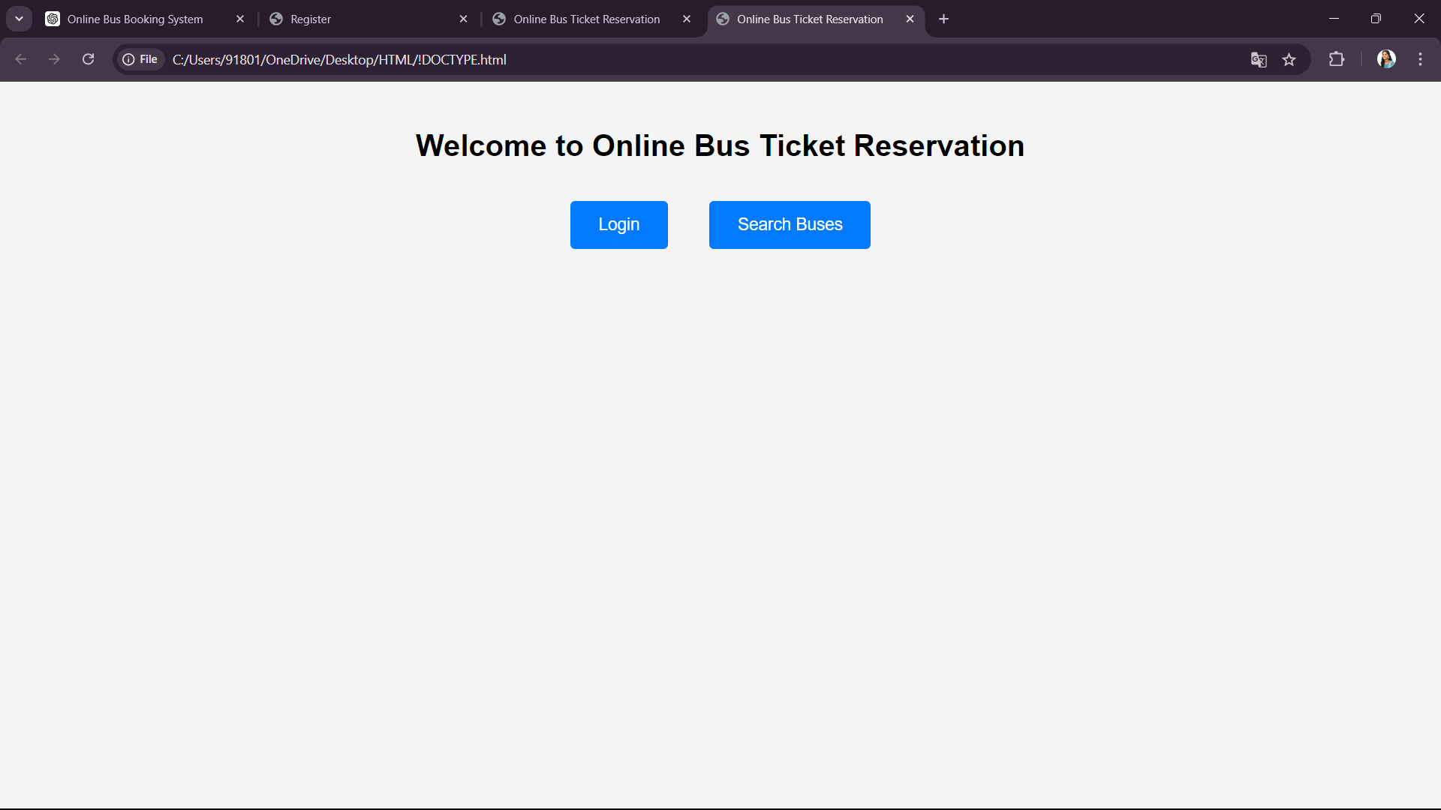

**2.login Details**

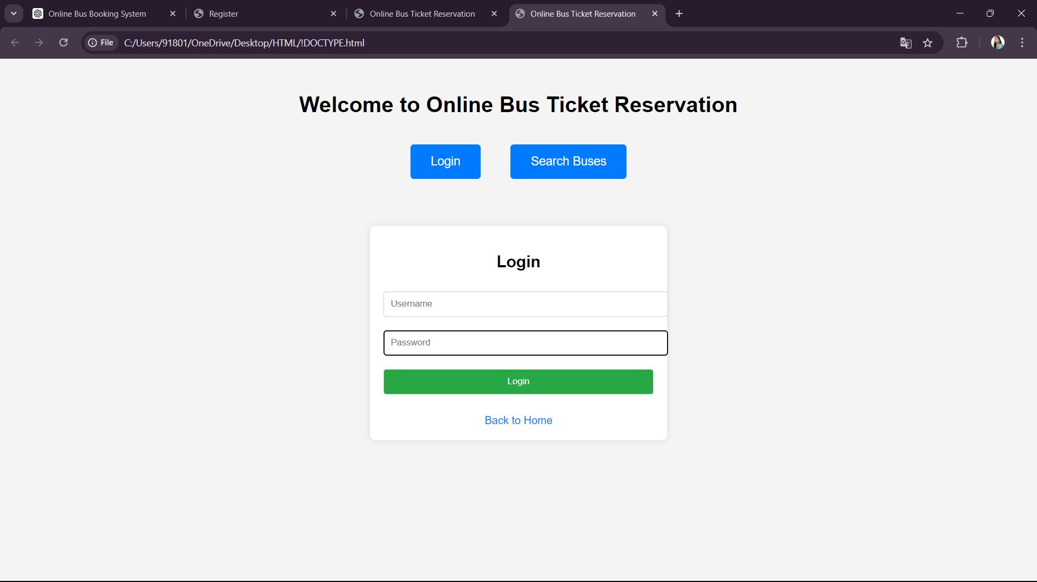

**3.Search for buses**

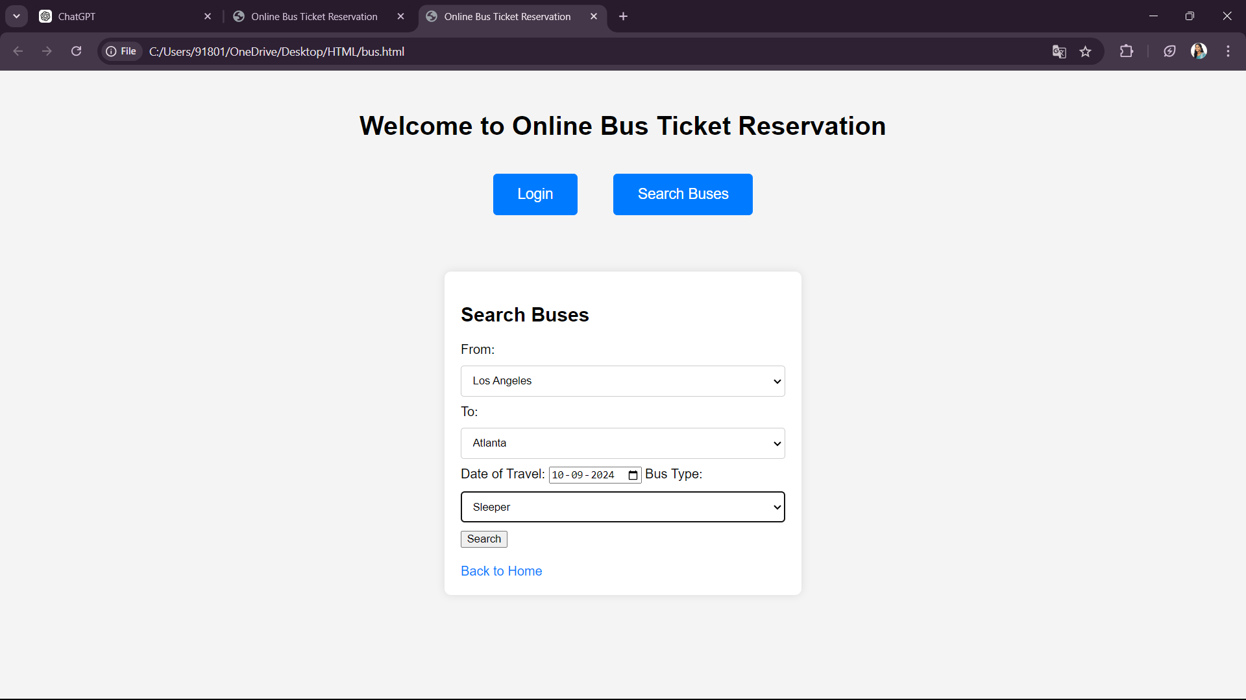

**4.Payment details**

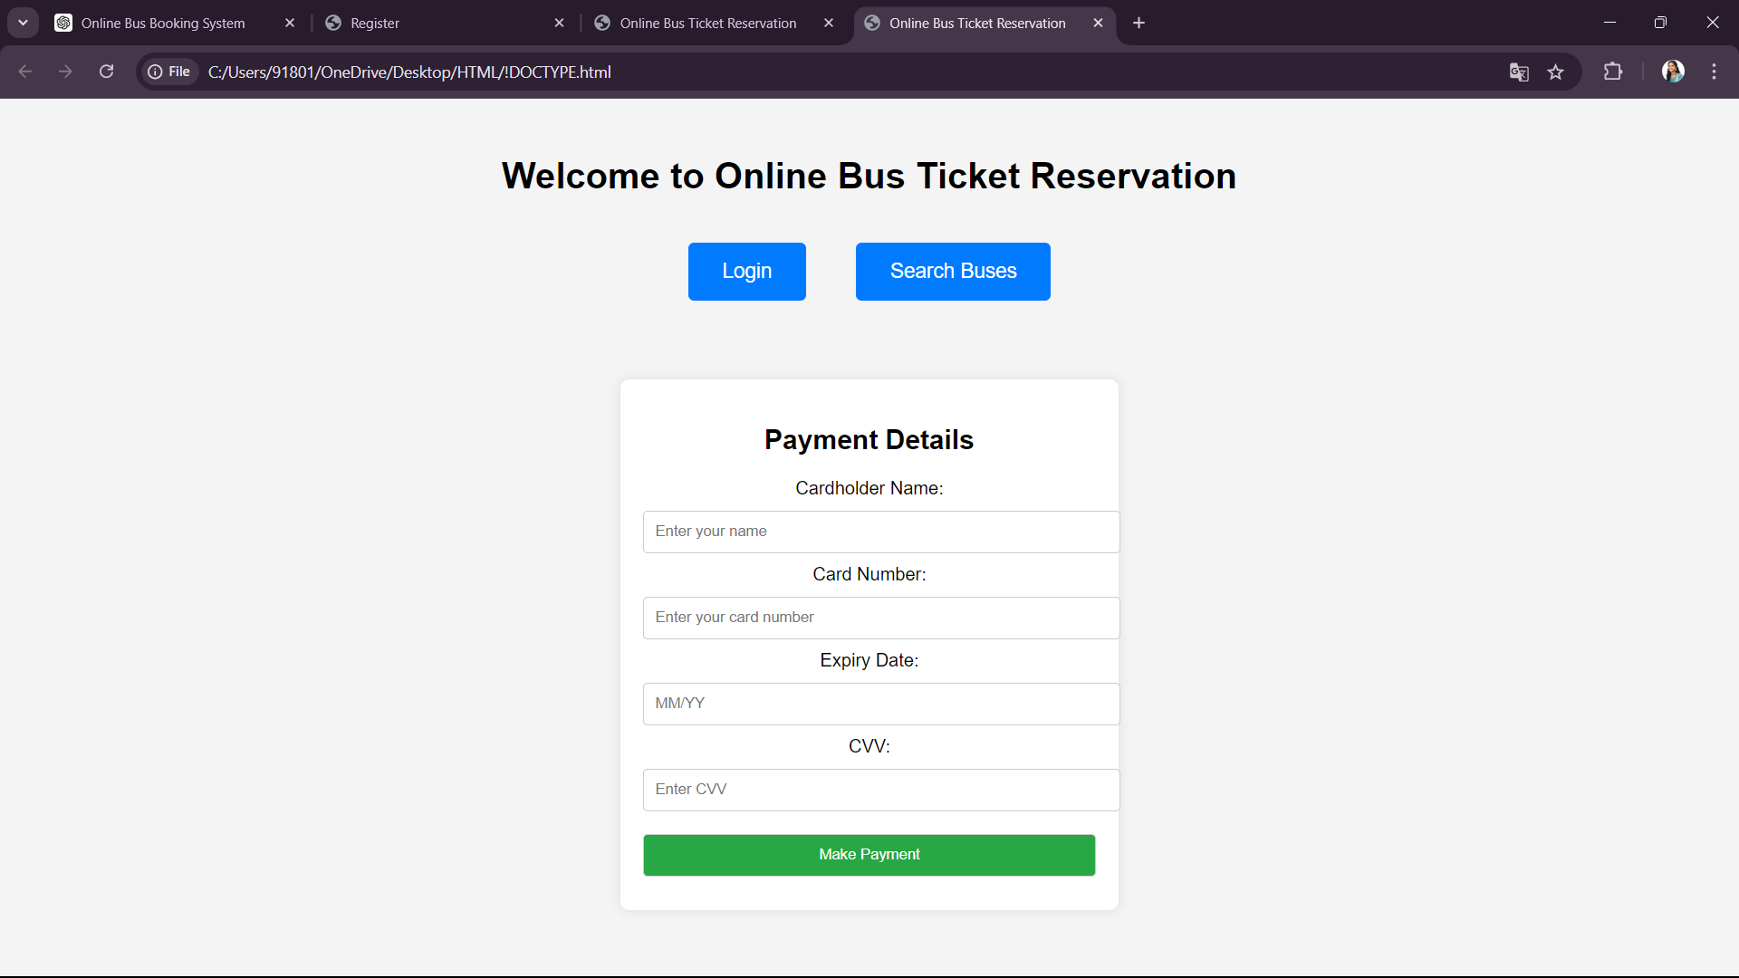

**5.Ticket Confirmation**

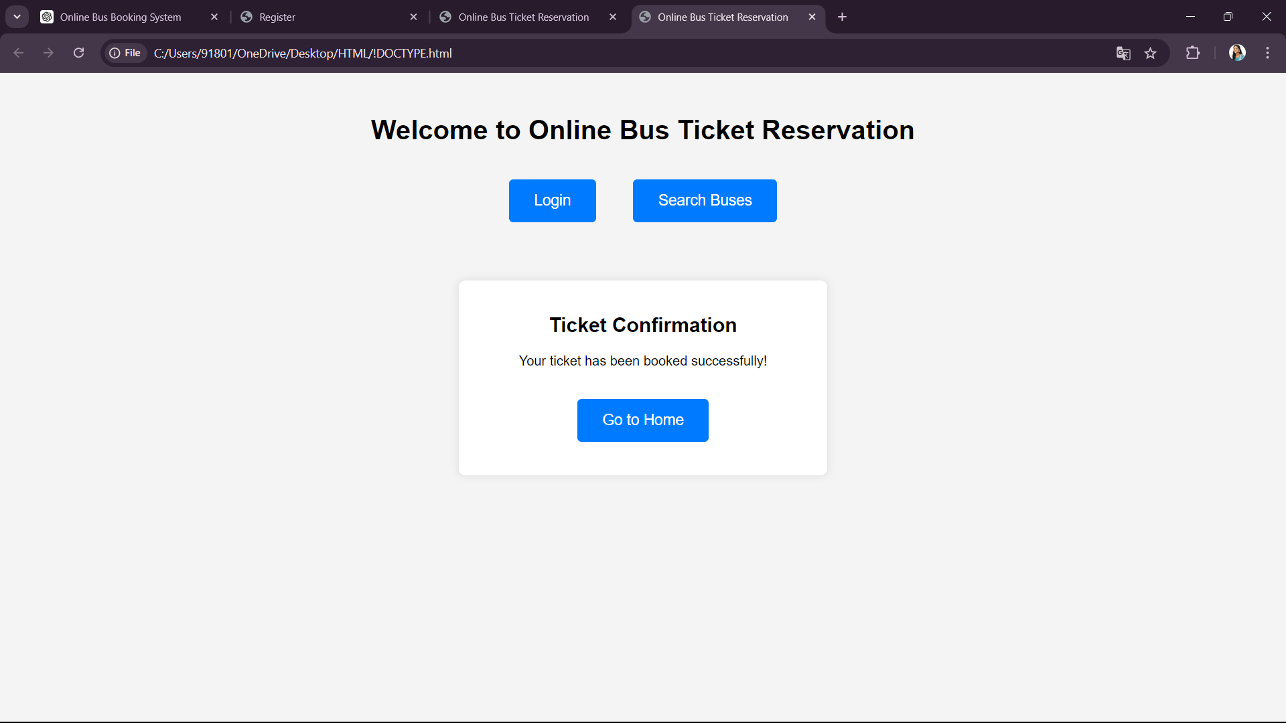

**CONCLUSION:**

The **Online Bus Ticket Booking System** offers a comprehensive solution for modernizing the bus travel experience, catering to the needs of both passengers and administrators. By integrating advanced features and user-friendly design, this system enhances the efficiency and convenience of booking bus tickets online.

**Summary of Benefits:**

1. **Enhanced User Experience**:
   * **Seamless Booking Process**: Users can effortlessly search for buses, select seats, and complete their bookings with secure payment options.
   * **Personalized Dashboard**: The personal dashboard allows users to manage their bookings, view history, and receive timely updates and confirmations.
2. **Streamlined Administration**:
   * **Efficient Management**: Admins have access to powerful tools for managing bus schedules, seat availability, and user accounts.
   * **Flexibility and Control**: Admins can add and update bus information, manage categories, and handle user feedback with ease.
3. **Responsive and Accessible**:
   * **Mobile-Friendly Design**: The system is optimized for various devices, ensuring a consistent and accessible experience across desktops, tablets, and smartphones.
4. **Robust Features**:
   * **Booking and Cancellation**: The platform supports both booking and cancellation processes, with integrated payment gateways and flexible policies.
   * **Feedback and Reporting**: Users can provide feedback through comments, and admins can generate detailed reports to monitor and improve service quality.
5. **Security and Compliance**:
   * **Secure Transactions**: The system employs secure payment methods and robust authentication processes to protect user data and transactions.

In conclusion, the **Online Bus Ticket Booking System** is designed to meet the evolving needs of travelers and bus operators. It simplifies the booking process, enhances user satisfaction, and provides valuable tools for effective management and reporting. By leveraging modern web technologies and a responsive design, the system addresses the challenges of traditional bus ticket booking, offering a reliable and efficient solution for both users and administrators.

**REFERENCES:**

1. AA Kayode, AO Alabi - Asian Journal of Research in …, 2021 - info.euro-archives.com
2. [S Sandiwarno](https://scholar.google.com/citations?user=9djnIi0AAAAJ&hl=en&oi=sra) - International Journal Of Computer Science And …, 2018 - academia.edu
3. AK Ibrahim, AB Ta'a - European Journal of Computer Science and …, 2015 - researchgate.net
4. [NI Cosmas](https://scholar.google.com/citations?user=wrbB9OYAAAAJ&hl=en&oi=sra), [C Etus](https://scholar.google.com/citations?user=anTjcCwAAAAJ&hl=en&oi=sra), [IU Ajere](https://scholar.google.com/citations?user=xMQ0wUAAAAAJ&hl=en&oi=sra), AU Godswill - Int J Comput Sci Stat, 2015 - researchgate.net
5. [MO Oloyede](https://scholar.google.com/citations?user=kgLxQTgAAAAJ&hl=en&oi=sra), SM Alaya, [KS Adewole](https://scholar.google.com/citations?user=M-ibKUMAAAAJ&hl=en&oi=sra) - **Development**, 2014 - academia.edu
6. [AR Mohammed](https://scholar.google.com/citations?user=Bt91IJAAAAAJ&hl=en&oi=sra), [SS Kassem](https://scholar.google.com/citations?user=CSEamIYAAAAJ&hl=en&oi=sra) - 2020 International Conference …, 2020 - ieeexplore.ieee.org
7. K Patel, P Patel, A Raidas - … Journal of Engineering **Development**and …, 2018 - rjwave.org
8. [ZM Alfawaer](https://scholar.google.com/citations?user=H1gVHdYAAAAJ&hl=en&oi=sra), [M Awni](https://scholar.google.com/citations?user=u3CUUdEAAAAJ&hl=en&oi=sra), S Al-Zoubi - International Journal of …, 2011 - researchgate.net
9. [AM Chircu](https://scholar.google.com/citations?user=UOuiCO4AAAAJ&hl=en&oi=sra), [RJ Kauffman](https://scholar.google.com/citations?user=kFJVSnoAAAAJ&hl=en&oi=sra), D Keskey - Communications of the ACM, 2001 - dl.acm.org
10. A Osmanzade - Tallinn University of Technology, Tallinn, 2021 - digikogu.taltech.ee